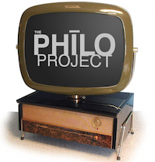

APPLICATION FOR SERVICES

The PHILO Project produces no-cost, high quality video for small Philadelphia area nonprofits with total yearly budgets of one million dollars or less. Only these nonprofits are eligible for PHILO’s services.

Please provide the following information along with your most recent federal tax form 990 (or that of your fiscal sponsor), your IRS 501(c)3 letter, no fewer than 3 supporting materials of your choice, and a 1 to 2 page plan outlining how you plan to use your PHILO video.

Once you have submitted this information via application@philoproject.org, PHILO will contact you via email.

Organization:

Address:

Organization’s 501(c)3 number:

Fiscal Agent (if any):

Fiscal agent’s 501(c)3 number:

Name of applicant:

Applicant’s title:

Applicant’s telephone number:

Applicant’s email address:

Organization’s mission:

Organization’s total budget (most recent fiscal year):

We need a PHILO Project video for (check all that apply):

Fundraising Crowdfunding Training Volunteer Recruitment Public Awareness / Publicity

Thanks for applying and good luck!

