PHILO PROJECT T-SHIRT ORDER FORM

THANKS FOR ORDERING YOUR 100% COTTON PHILO PROJECT T-SHIRT!

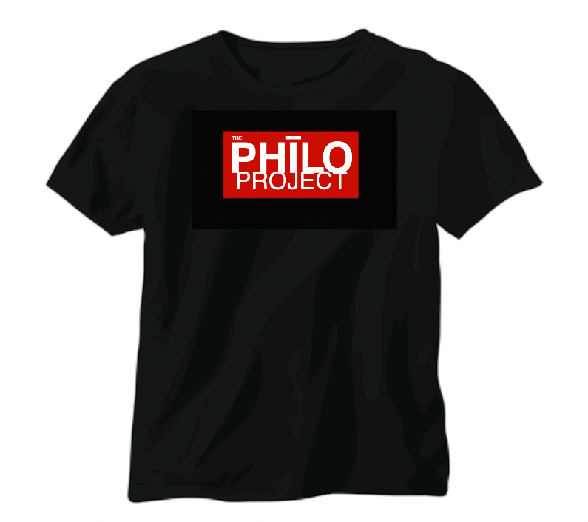

NAME:

MAILING ADDRESS:

EMAIL:

SIZE SMALL QUANTITY: 1 2 3 4 5

SIZE MEDIUM QUANTITY: 1 2 3 4 5

SIZE LARGE QUANTITY: 1 2 3 4 5

SIZE EXTRA LARGE QUANTITY: 1 2 3 4 5

SIZE 2XL: QUANTITY: 1 2 3 4 5

PLEASE EMAIL THIS FORM TO philo.tshirt@gmail.com

ALLOW 4 -6 WEEKS FOR DELIVERY

